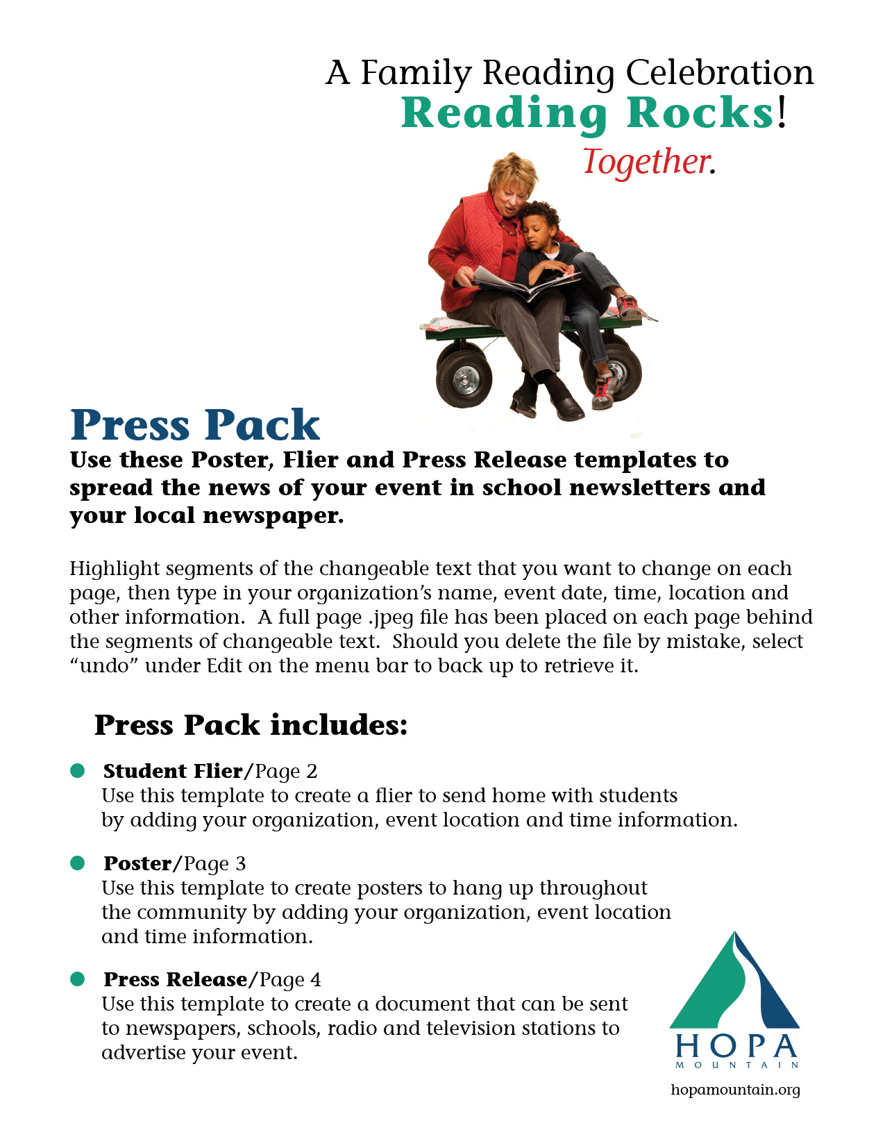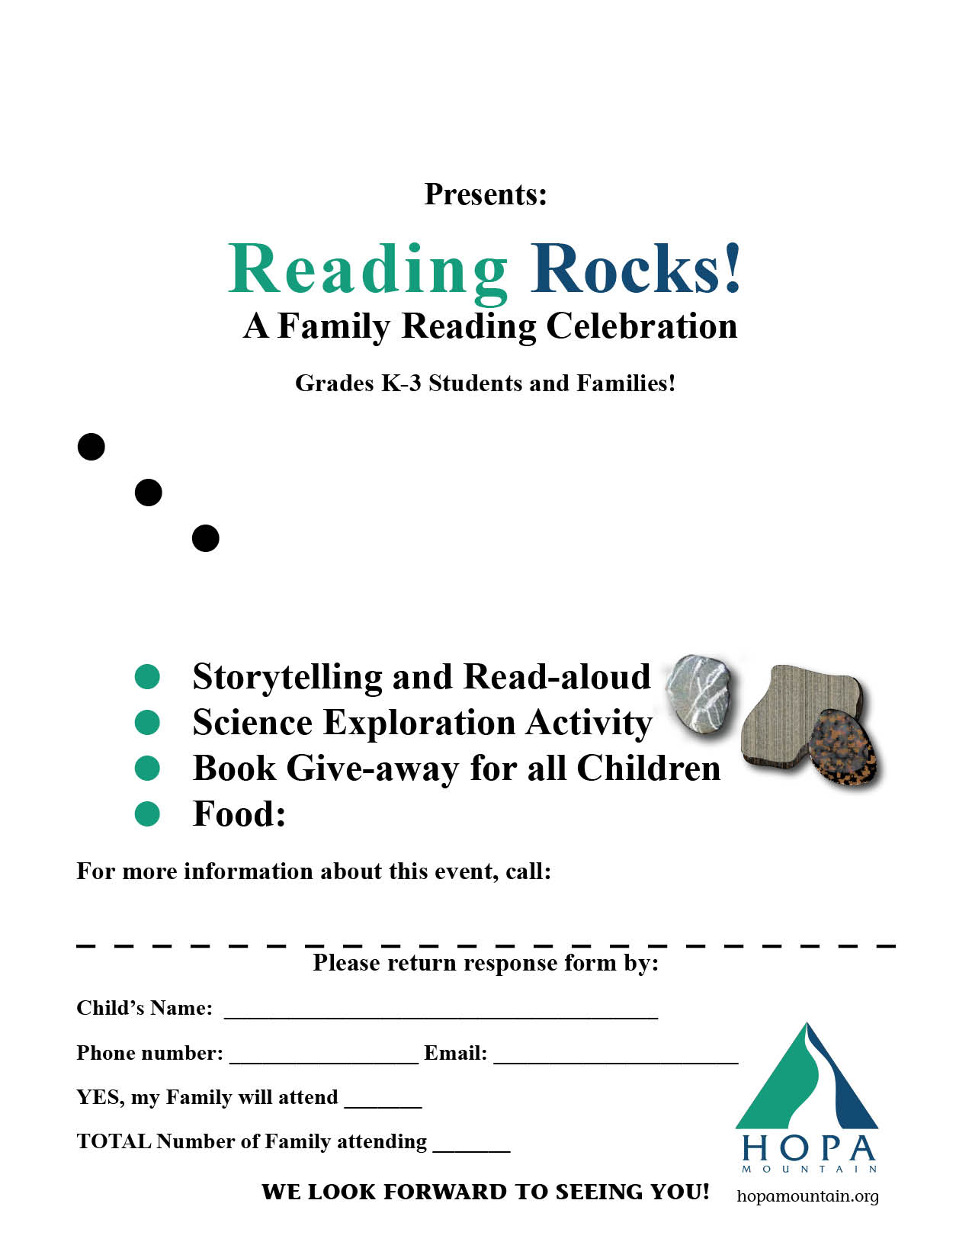

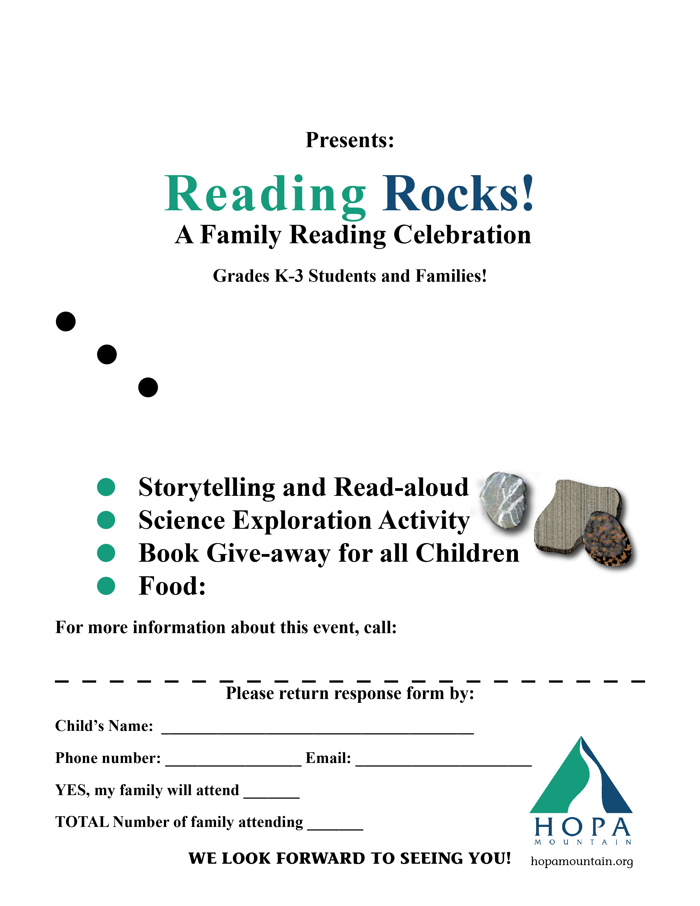

**Insert Organization Name**

**Insert Date of Event**

**Insert Time of Event**

**Insert Location of the Event**

**INSERT ADDRESS WHERE EVENT WILL BE HELD**

**Insert food information here**

**NAME PHONE E-MAIL**

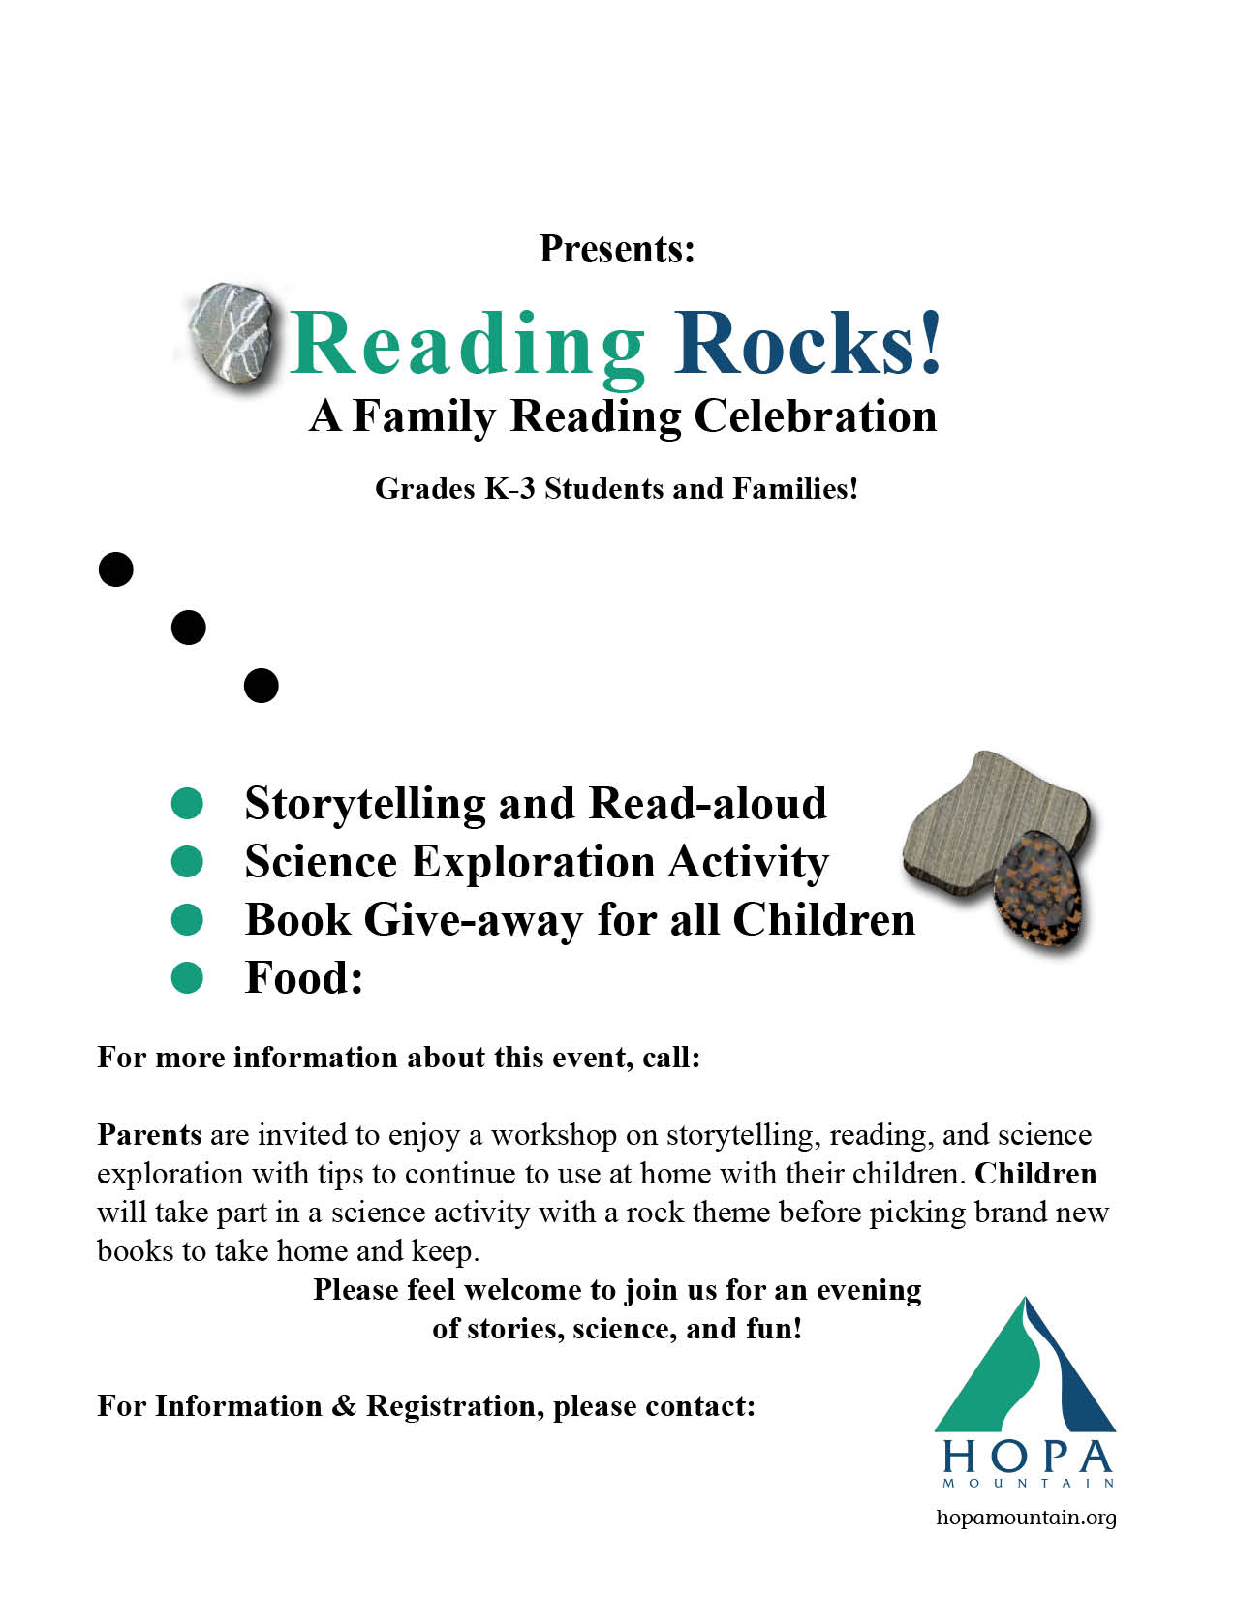

**Insert Organization Name**

**Insert Date of Event**

**Insert Time of Event**

**Insert Location of the Event**

**Insert Address where event will be held**

**INSERT FOOD INFO HERE**

**Insert Contact Name, Phone and Email**

**PRESS RELEASE**

**Reading Rocks**

**A Family Reading Celebration**

**SUBJECT:**

A Family Reading Celebration will be hosted by **[your organization name]**.

**CONTACT:**

**[Contact information: name, phone number, email, etc.]**

**FOR RELEASE:** On receipt

**[Insert your organization name here]** will host ***Reading Rocks! A Family Reading***

***Celebration*** on **[insert date here]**. Parents are invited to enjoy a workshop on storytelling, reading, and science exploration with tips to continue activities at home with their families. When families interact positively together by talking throughout the day, reading and telling stories, and engaging in fun, imaginative play, their children are more likely to do well in school and lead happy, healthy lives. These nurturing experiences factor in healthy brain development and help strengthen the important bond that exists between children and their parents or caregivers.

During the ***Reading Rocks!*** event, children will take part in a science activity with a rock theme before picking brand new books to take home and keep.

“*By getting books in the hands of caregivers and children, we want to encourage rich early learning experiences at home that can make a big difference in the development of a young child. Reading is just one kind of vital interaction — the key is positive language development through storytelling, singing or just talking together.*”

- Bonnie Sachatello-Sawyer, executive director of Hopa Mountain.

A vast body of research has proven the many benefits of exposure to language—through talking, singing, and reading — on the developing brains of babies and children. Story time is also an important bonding time between parents and children.

Please feel welcome to join us for an evening of stories, science, and fun! Please call or email **[insert your contact’s name and information]**.